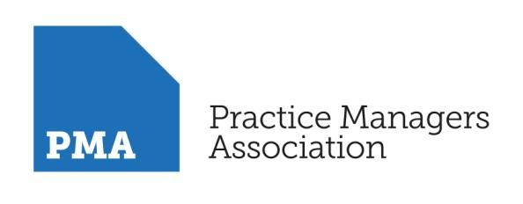

THE BUSINESS OF GENERAL PRACTICE

MODULE: Managing Practice Finances - Practice Finance & Income Streams – Reducing Costs, Payroll and an understanding of the PCN landscape

25th November 2020

9.00am - 12.30pm

Gloucester CCG
To Register, please - click here
After registering, you will receive a confirmation email containing information about joining the meeting and you will be able to add the details to your calendar.

Overview: This is the foundation workshop to the PMA programme – a series focused on the business management of general practice - and managing practice finance will all be explained in a user-friendly, interactive way. The web workshop will also take a look at the PCN landscape and explore financial issues of the working at scale models – where costs are reduced and new funding and income stream. The group work encourages participation so that individual issues can be explored.

The module will be delivered as an interactive web workshop with practical guidance to enable participants to map the techniques and outcomes onto their own practice.

Objective: Participants will gain an understanding of practices finances and how to understand the accounts produced by your accountant. You will also gain an understanding of practice finances, Primary Care Network finances and how important managing these areas lead to reduced financial risk in the ever-changing world of general practice.

PROGRAMME
- Web Workshop -

Introduction and Welcome

Managing Practice Finances - Overview

Contract Changes 2020

Understanding Accounts
  - Accounting Terminology
  - Types of Income and expenses
  - Variance analysis
  - Debtors and Creditors
  - Current and capital accounts explained
  - Drawings
  - Payroll
  - Property ownership - accounting treatment and buy-in / selling

Practice Finances
  - Financial Benchmarking & Budgeting
  - Cash-flow forecasting
  - IR35
  - GMS/PMS Contract Changes - Contract changes on the horizon

Primary Care Networks and the future of Primary Care
  - PCN Funding
  - Funding Streams / To individual practices/ Extended hours
  - Extended access funding
  - Accounting at practice level
  - Workforce mix
  - VAT
  - Employment status of Clinical Director
  - Investment
  - Workforce

Employee issues
  - Shared resources
  - Employee liabilities
  - Pension tax – calculations (Annual Allowance / Lifetime Allowance) and options from a tax perspective
  - VAT

Reflective session – Open Forum
Reflection and open discussion of challenges or concerns.

CLOSE

The Facilitator – Katy Drew

Katy Drew LL.B. F.C.A. A.L.C.M.
Primary Care Development Manager
Sandison Easson Specialist Medical Accountants

Katy Drew is a Chartered Accountant who has a wealth of knowledge at the forefront of Primary Care Management and Finance.

As Primary Care Development Manager at Sandison Easson Specialist Medical Accountants she helps Practices to be resilient in the current climate through practical help and advice leading to strong financial management.

Having spent part of her career in practice management she is keen to support managers in translating financial information so they are able to present data in an accessible and understandable way to GP partners.

She is a motivational and enthusiastic trainer who inspires confidence in those she works with at both individual practice level and through courses and conferences.

